DIGITAL MARKETING PRO COURSE

**Milestone 1: Fundamentals of Digital Marketing Live Class 6: Metrics & Ratios**

**Metrics & Ratios related to the Marketing Funnel**

## What are Metrics?

In Digital Marketing, metrics are the key performance indicators (KPIs) used to measure the success of a business's marketing efforts online. The goal of using digital marketing metrics is to track and decipher the way consumers interact with your brand online through websites and social media platforms.

## 3 Phases of Digital Marketing Funnel

1. Lead Generation Phase - Top of Funnel - TOFU
2. Lead Nurture Phase - Middle of Funnel - MOFU
3. Sales Phase - Bottom of Funnel - BOFU

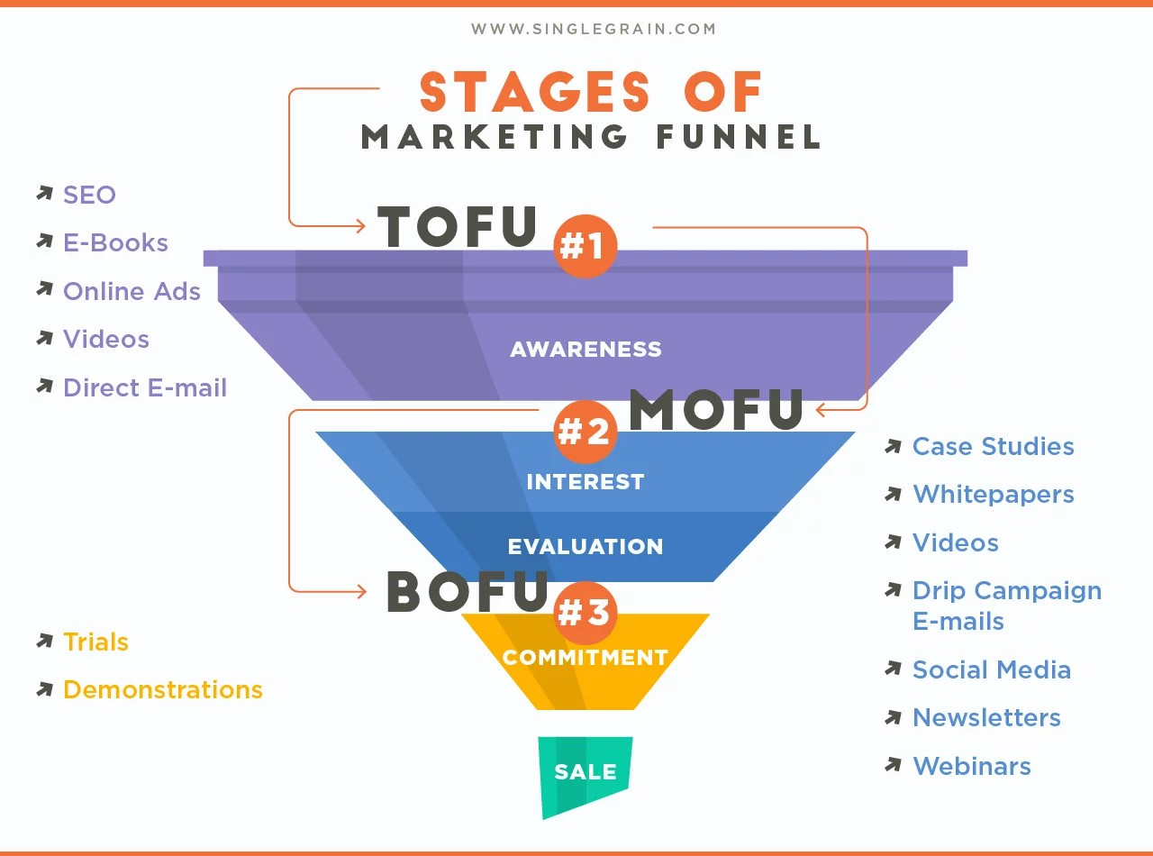

# TOFU

* + Impression: Total number of Views. It is also referred to as an "ad view."
  + Reach - A Total number of individuals who have seen your ad or content.
  + Frequency: How many times an individual has seen your ad or content? Frequency = Impression / Reach
  + Click Through Rate: It is the ratio of users who click a link to the total number of users who view it. CTR = Number of clicks / Number of impressions X 100

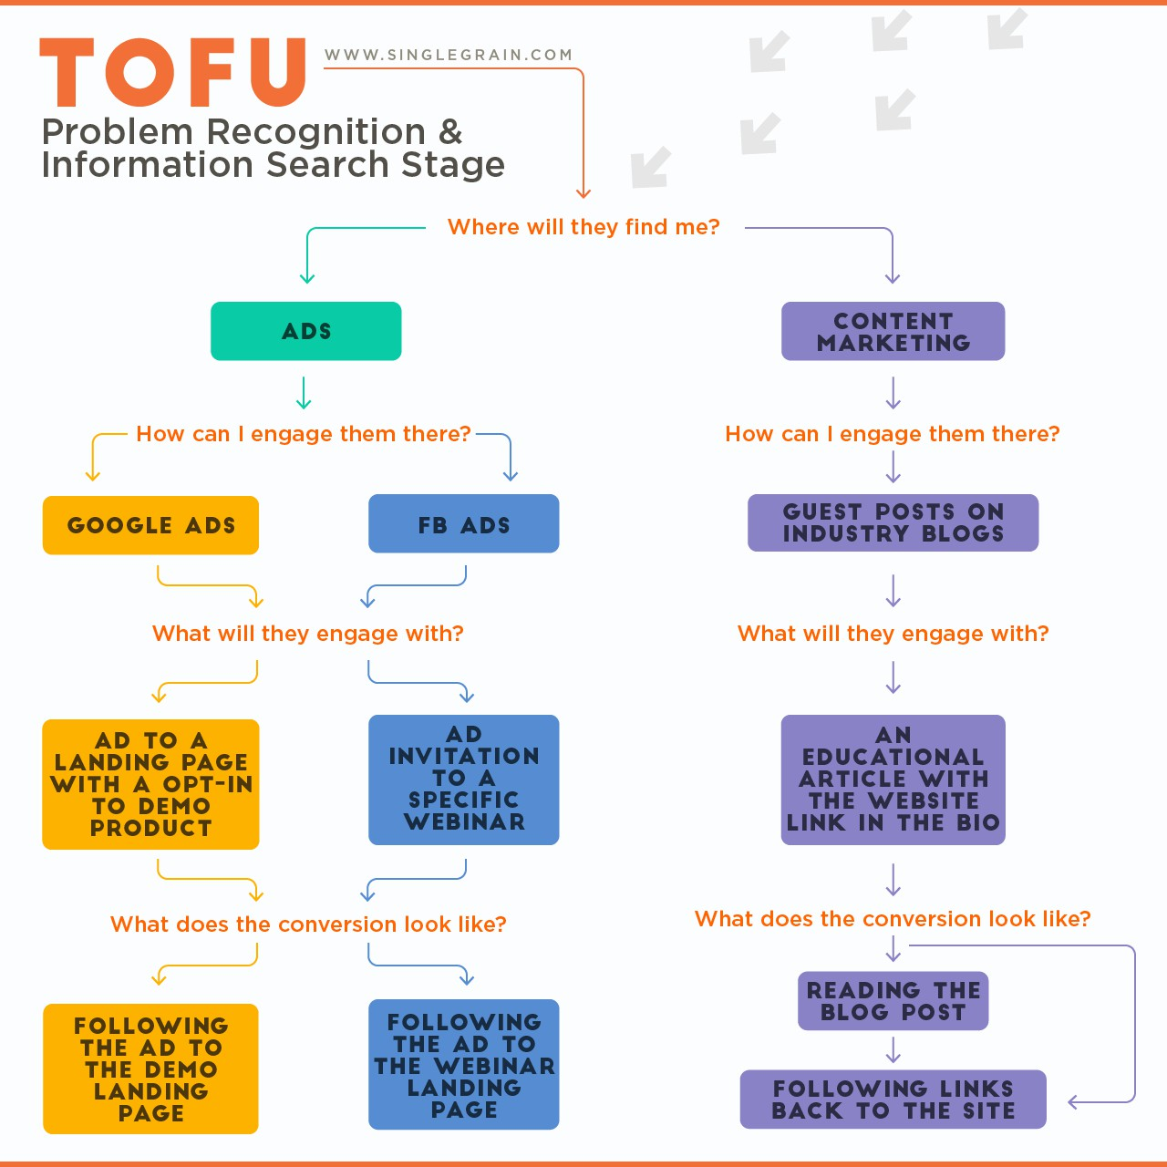

# MOFU

* + Cost per Click: It shows how much you pay when your ad is clicked. CPC is used to assess the cost-effectiveness of an ad campaign. CPC = Ad costs / Number of clicks
  + Cost per Landing page View: It shows how much you pay for the search engine when a prospective customer enters your website's landing page. CPLV = Cost of an ad / Total number of Landing page views
  + Bounce Rate: The percentage of visitors that leave a webpage without taking an action. BR = (No. of single-page sessions / No. of total sessions on the site) X 100
  + Average Session Duration: Time spent on the website
  + Abandon Rate: The percentage of abandoned carts in a business. AR = No. of abandoned shopping carts / No. of initiated actions X 100

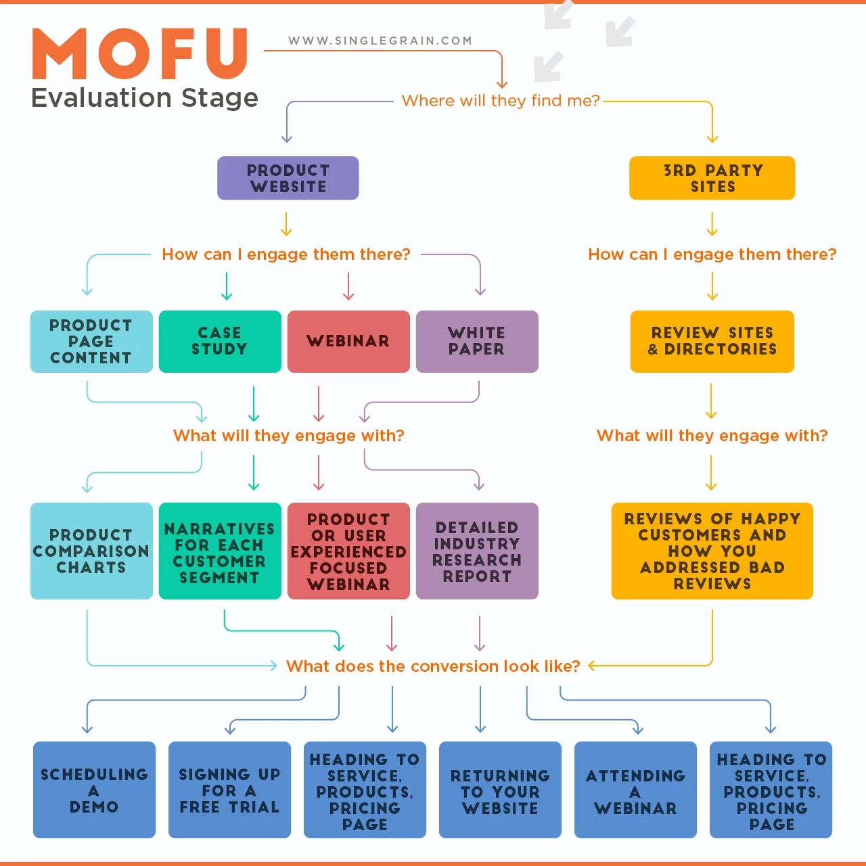

# BOFU

* + Conversion Rate: This metric indicates the number of users that saw your ad and took action as a result.

CVR = Number of purchases / Number of add-to carts X 100

* + Customer Retention Rate (CRR): The customer retention rate is also called reversed customer churn.

CRR = (No. of customers at the end X No. of customers acquisition / No. of customers at the beginning) X 100

* + Cost per Acquisition/Cost Per Transaction: It gives you an estimate of how much your new customers are costing you.

CAC/CPT = Total cost of a campaign / Number of conversions

* + Average Cost of Sale – ACS = Cost to inventory items based on the total cost of goods purchased / total number of items purchased.
  + Return On Ad Spend ROAS = Revenue attributable to ads / Cost of ads For example, if you invest Rs. 100 into your ad campaign and generate Rs. 250 in revenue from those ads, your ROAS is 2.5.
  + Return on Investment ROI = Net income / Cost of campaign x 100 For example if your total income is Rs. 1,000 and the marketing campaign cost Rs. 200, then the simple ROI is 400%. ((1000-200) /200) X 100 = 400%. (Net Income = total income - the cost of the campaign)
  + Average Order Value: The average amount spent each time a customer places an order on a website or mobile app.

## Difference between D2C and B2C Marketing

**D2C - Direct to Consumer** businesses are typically companies that manufacture as well as sell their products to customers directly.

Examples - **Lenskart, Licious**, etc.

**B2C - Business to Consumer** businesses are those activities that acquire goods from the producers and then sell them to customers directly. They are not the producers.

For example - **Udemy** does not own or create the content that it is selling, and a pharmacy (medical shop) does not manufacture the medicines but directly sells them.

## What is a Website Analysis and why is it important?

A website analysis is a process of assessing the performance of a website in key areas like speed, design, engagement, conversions, etc. In short, all the factors that can affect the user experience and in turn the conversion rate.

Once you enter the field of digital marketing, your website is the primary online representation of your company/product. A well-designed and optimised website could be the difference between a successful product and an unsuccessful one. To optimise your website, you have to know what it lacks and what the customers need which can only be known through proper analysis.

## Website Analysis - Neemans

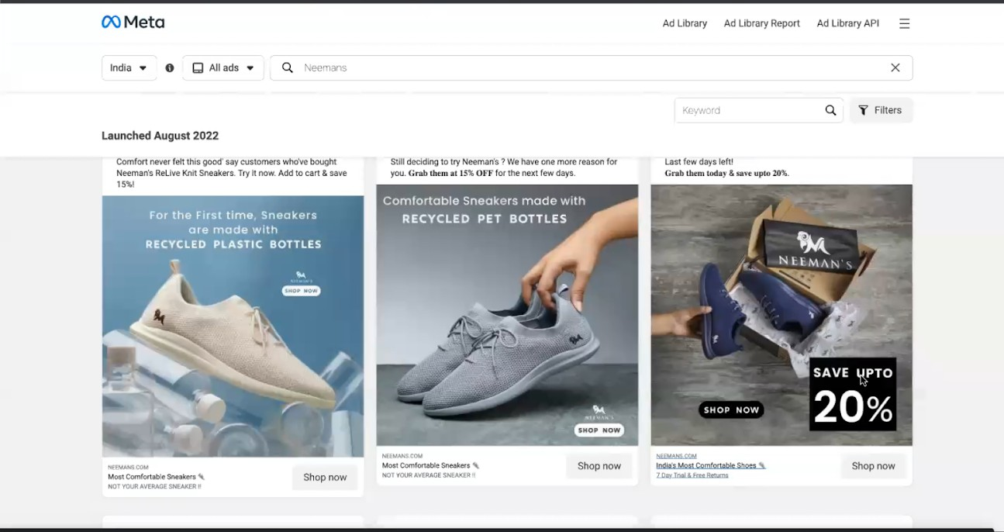

The **‘SAVE UPTO 20%’** tells us that the customer persona is price sensitive, that is they are not concerned about the brand as much as they are about the price and discounts.



**‘India's most comfortable shoes’** signify one of their USPs, which is Comfort.

## “7 Day trial & free returns”

If both of these statements were included on the product image as a banner instead it would be more noticeable to the viewers and could lead to higher **CTRs** (Click through rate).

The call-to-action button says **‘SHOP NOW’** - the other options could be **‘explore now’**

or **‘buy now’.**

The views on choosing the CTA can vary according to different approaches; an amazon seller would only want the traffic on his website that wants to buy and not explore hence he chooses the buy now option. But an alternative approach would be that, how do we know whether the exploratory traffic will convert to buyers or not therefore an ‘explore now’ button should be added to increase engagement time.

To resolve this a simple AB test can be done that determines which of the above approaches results in higher conversions.

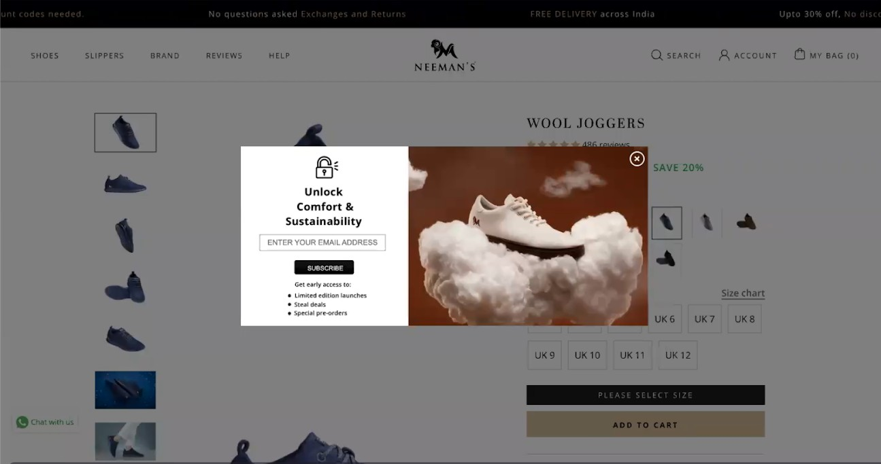

Pop-up asking for email id post clicking on **‘Shop now’** - A pop-up asking for your email id after you click on the CTA button for a product acts like a roadblock and is ill-timed at

this point of the funnel, which is very critical for conversions. The information requested is also not very relevant to a shoe company at this stage either.

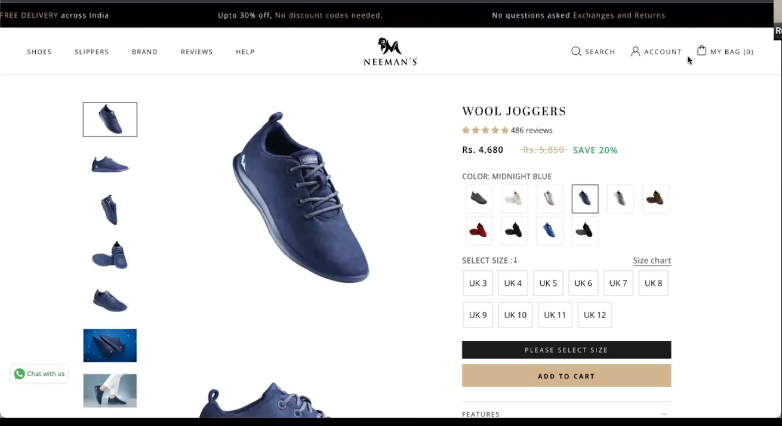

There are two CTA’s on the product page - **‘Please select a size** and **‘Add to cart’**

Out of which **‘Add to cart’** seems to be the more prominent button and ‘**please select a size’** serves more as a prompt rather than a button because there are dedicated buttons for selecting size and as soon as the size is selected the prompt changes to a ‘Buy now button.

If you directly click on the **‘Add to Cart’** button the website prompts you to select a size first. This chain of action points to repetitive behaviour and the first CTA button for selecting size essentially serves no purpose because we cannot add to the cart without selecting a size anyway.

The add-to-cart button also changes colour to black when you hover over it which is neither aesthetically pleasing nor does it follow the principles of colour psychology.

Here, only one CTA button for adding to the cart is required to move on to the next step of the funnel.

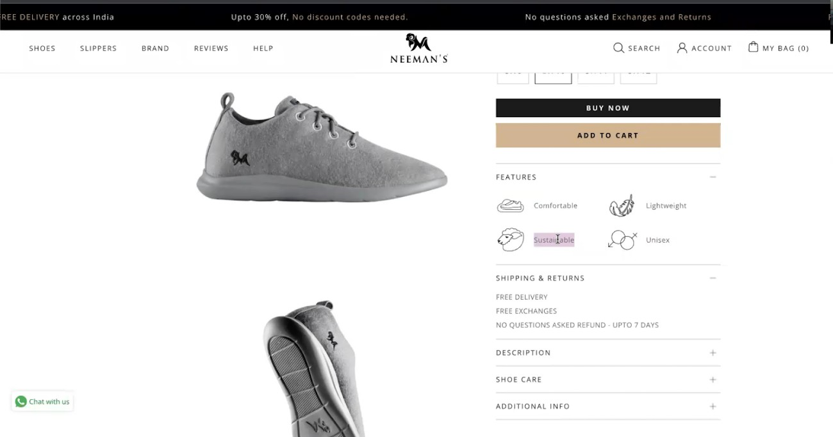

The features correctly give relevant information about the product but the two factors (7-day trial and free return) that lead to the Click on the CTA button seem to be missing from the top of the page and are located in a small drop-down at the bottom which is a major mismatch.

Overall the flow of the website is not very well connected between the stages of the funnel, there are irrelevant pop-ups in between steps and it is hard to navigate through the website. Some reviews give us the primary credibility signal and the pictures of the products properly depict it.

The website, instead of enhancing the product and enabling easy navigation, adds unnecessary design elements that are unsettling and irrelevant to the product and process.

## Website Analysis - TATA 1mg

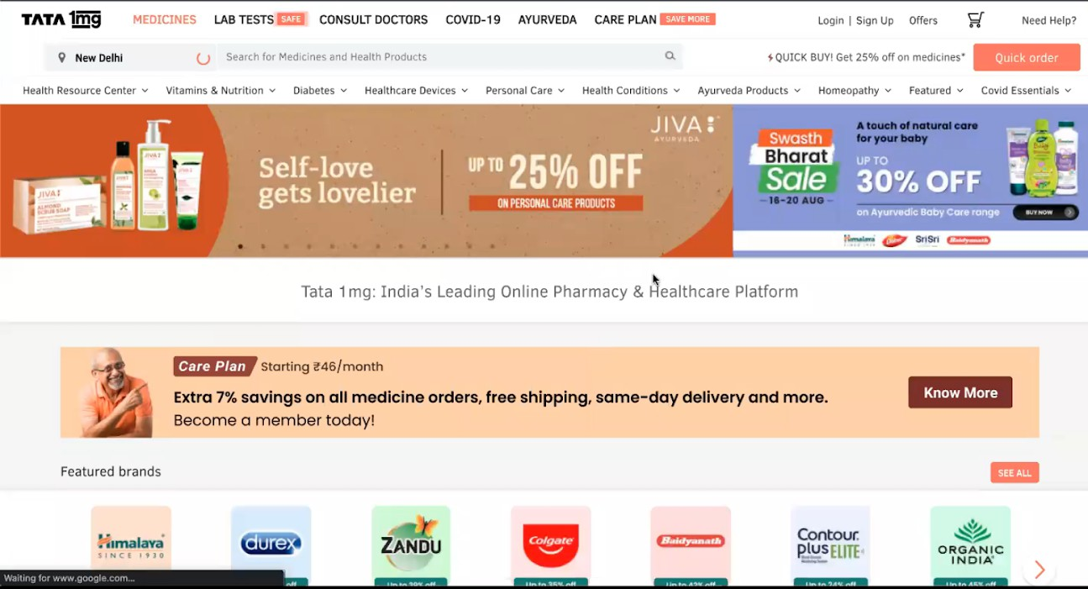

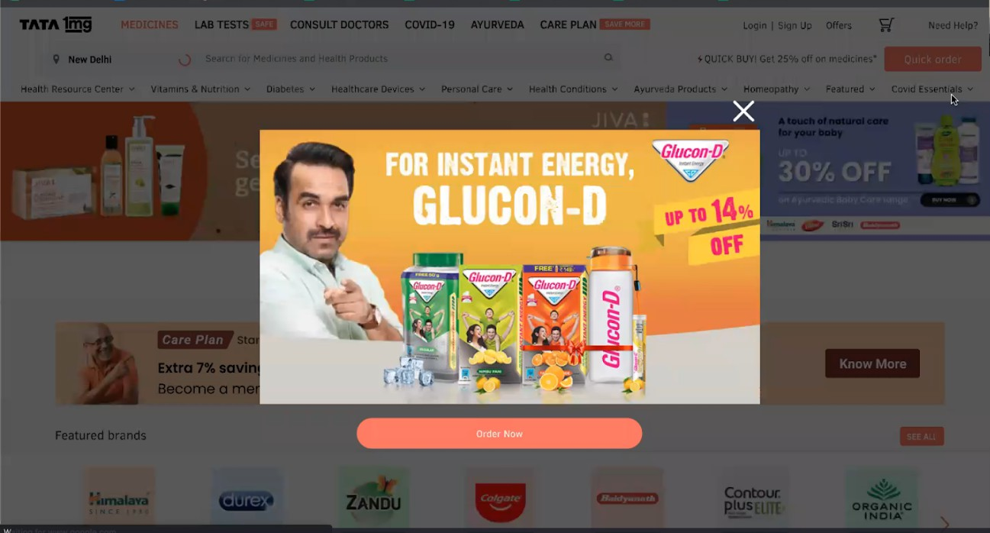

As soon as you launch the Website a prompt pops up with an actor as a product ambassador.

The website is primarily for ordering medicines online and the first element you see is a non-medicinal product being promoted by an actor that is not directly related to the field or the product.

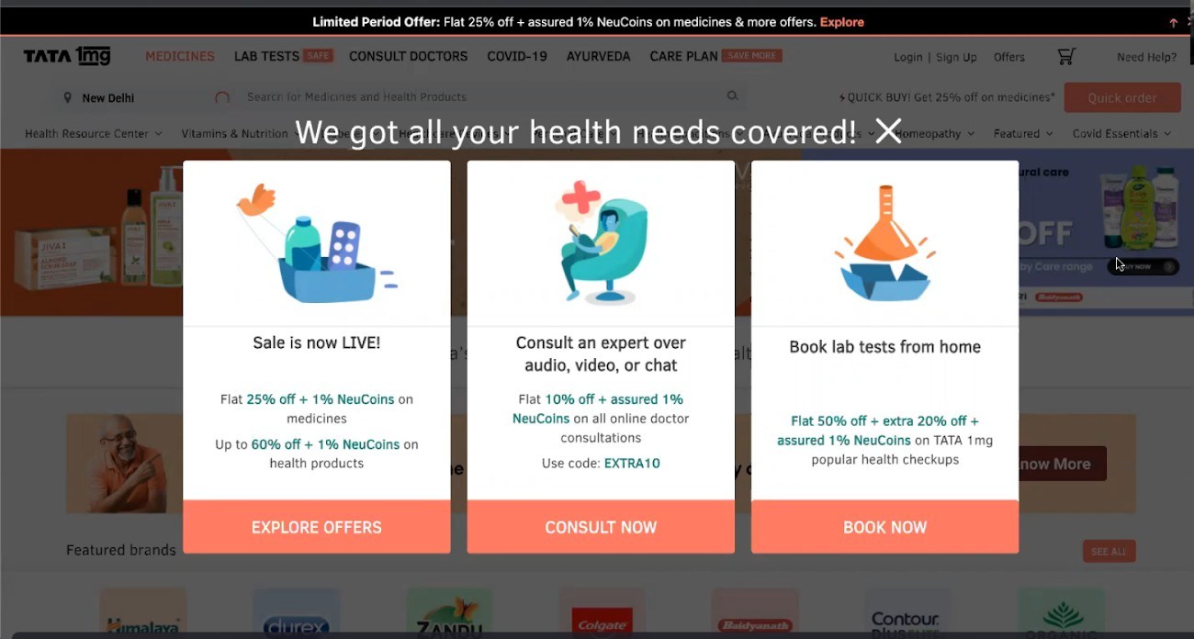

After you close the first pop up it is immediately followed by another pop-up. Running into two pop-ups as soon as you land is a very frustrating and offsetting experience for the visitor.

The layout of the website is also very cluttered making it hard to locate relevant elements, multiple banners in different locations give off the impression that the website is trying to do a lot of things at the same time but it accomplishes nothing apart from bombarding the visitor with information that may or may not be relevant to them.

## Website Analysis - PharmEasy

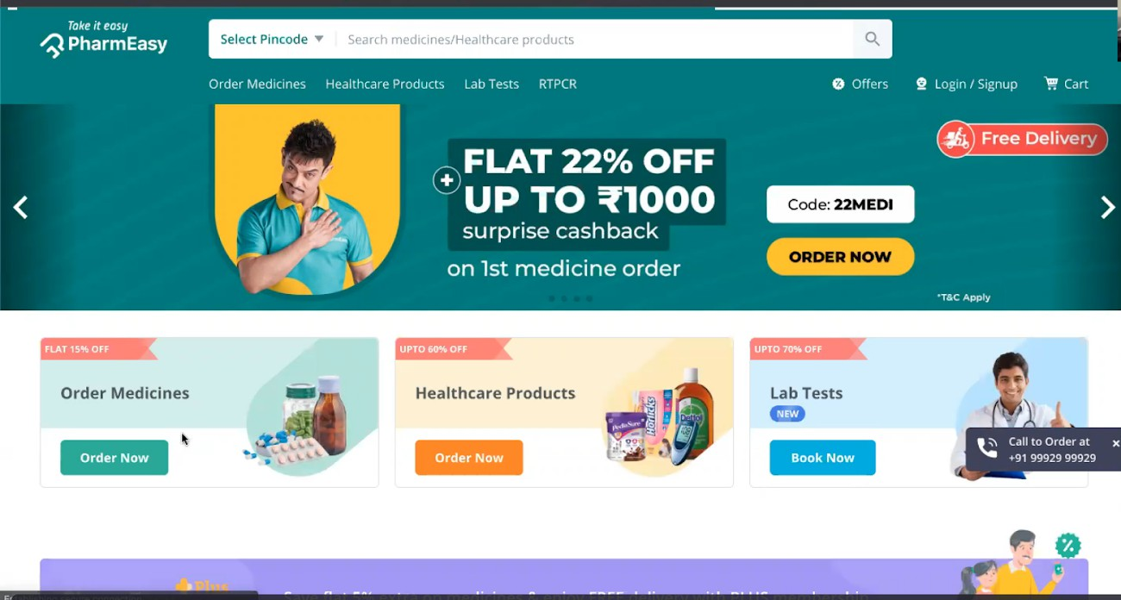

The first thing you notice after landing is the subtle green theme of the website and a well-defined layout. There are only three broad elements: Order medicines, health care, and lab tests All the elements follow the principles of colour psychology and induce feelings of peace and royalty (purple).

The banners and layout are well placed and very relevant as PharmEasy is primarily a medicine company, there are no unnecessary elements or distractions to interrupt the funnel. A visitor will have a much easier and more peaceful process on this website as compared to the previous ones.

To analyse the landing page of a website, you have to adopt a holistic approach that considers all of the elements like design, product, user interface, tone of the banner/header, etc.

You have to see the website from an ideal customer's perspective to analyse what ticks the customer and what doesn’t and how each element directly or indirectly impacts the conversion rate.